Problem 11.10 #8

libname ban500 '/home/nilunra0/my_courses';

**data** random;

/*the DATA step automatically names each successive data set */

do i=**1** to **1000**;

x=int(rand('uniform')\***5**)+**1**;output;

end;

/*here am using rand function to get random value between 1 and 5;*/

**run**;

**proc** **freq** data=random;

tables x/missing;

**run**;

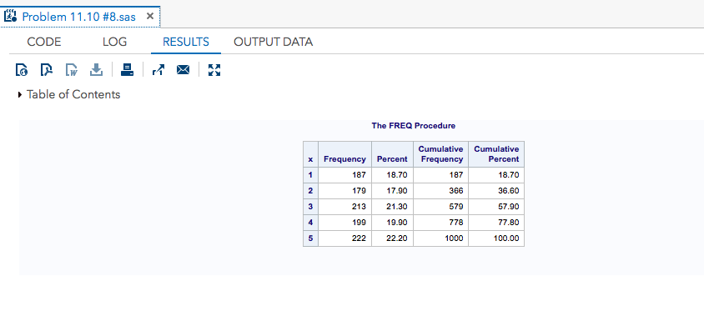

Problem 13.10 #5

libname ban500 '/home/nilunra0/my_courses';

**data** passing;

/*the DATA step automatically names each successive data set */

array pass_score{**5**} _temporary_

(**65**,**70**,**60**,**62**,**68**);

array Score{**5**};

input ID : $3. Score1-Score5;

NumberPassed = **0**;

do Test = **1** to **5**;

NumberPassed + (Score{Test} ge pass_score{Test});

end;

drop Test;

/*DATALINES statement with an INPUT statement to read data that you

enter directly in the program, rather than data stored in an external file.*/

datalines;

001 90 88 92 95 90

002 64 64 77 72 71

003 68 69 80 75 70

004 88 77 66 77 67

;

title "Listing of PASSING";

**proc** **print** data=passing;/*Selecting Variables to Print*/

id ID;

**run**;

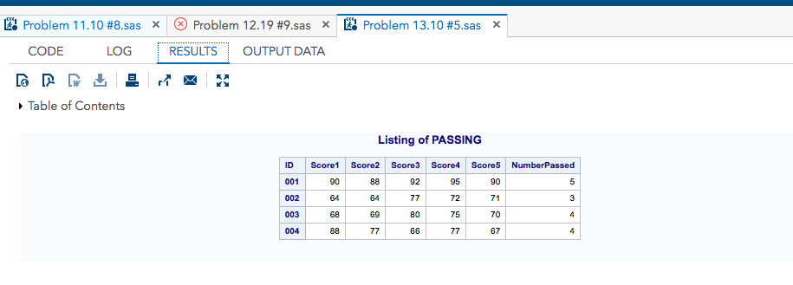

Problem 12.19#9

